KVG Ayurveda Medical College & Hospital Sullia Dk
PG Students list-2016-17

SN | Course | Name  *Remarks if any... |  | Blood Group | Father Name | Mother Name | Permanent Address  Phone Number | Sex | Student Adress  Cell No.  Email ID | Caste | Nationality | Seat  Category | PGET  Rank | PGET  % | Qualifying  Exam | Register  No. | Passed  year | University/  Board | Max  Marks | Sec.  Marks | Date  of  Admission | Date  of  Birth
1 | MD Ayurveda in Dravyaguna | Dr. Rachana N | 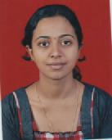 | AB+ | Padmanabha Bhat N | Usha P. Bhat | Nooji House  Badiadka  Peradala Post  Kasaragod Dist  KERALA-671551  9745943304 | Female | Nooji House  Badiadka  Peradala Post  Kasaragod Dist  KERALA-671551  9745943304  rachananoojibhat@gmail.com | General Merit | Indian  Kerala | Management Seats | 0 | 0 | BAMS | 10A0946 | 29-04-2015 | Rajiv Gandhi University of Health Sciences, Karnataka | 2350 | 1478 | 15-10-2016 | 19-08-1992
2 | MD Ayurveda in Dravyaguna | Dr. Rajan Dheeraj N | 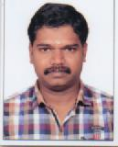 | B+- | N.S Rajan | N.K Renuka | Neellari Thaivalappil House  Kandanassery  Thalapilly TQ  Thrissur Dist  KERALA-680102  9496349460 | Male | Neellari Thaivalappil House  Kandanassery  Thalapilly TQ  Thrissur Dist  KERALA-680102  9496349460  rdeerajn@gmail.com | General Merit | Indian  Kerala | Management Seats | 0 | 0 | BAMS | 1136 | 12-10-2010 | University of Calicut | 1850 | 1005 | 19-10-2016 | 03-09-1985
3 | MD Ayurveda in Dravyaguna | Dr. Gayathri B | 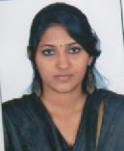 | B+ | T.P.S Balachandran | V Rama | 24/18  Door No. -02  Bhavani Flats  Ambedhkar Street  Saligramam  Chennai- 93  044-23624089  7358595463 | Male | 24/18  Door No. -02  Bhavani Flats  Ambedhkar Street  Saligramam  Chennai- 93  044-23624089  7358595463  Gayathri271591@gmail.com | General Merit | Indian  Tamil Nadu | Management Seats | 0 | 0 | BAMS | 64091315 | 21-10-2014 | The Tamil Nadu Dr. M.G.R University Chennai | 1850 | 1124 | 22-10-2016 | 27-10-1991
4 | MD Ayurveda in Dravyaguna | Dr. Kiran Achutha Bhat | 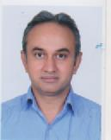 | B+ | A Achutha Bhat | Hema | Bhoovana  Kav Post  Puttur TQ  Dakshina Kannada Dist  KARNATAKA  9901142614  9731537914 | Male | Bhoovana  Kav Post  Puttur TQ  Dakshina Kannada Dist  KARNATAKA  9901142614  9731537914  swaveda@hotmail.com | General Merit | Indian  Karnataka  Rural | Management Seats | 0 | 0 | BAMS | 561 | 07-05-1999 | University of Kerala | 1850 | 1085 | 22-10-2016 | 28-11-1974
5 | MD Ayurveda in Dravyaguna | Dr.Chaitra K. | 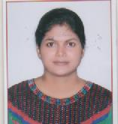 | A+ | Padmanabha Bhandary | Hamsavathi | Mithrampady House, Kedambady Post, Puttur T.Q., D.K., Karnataka-574210 8762119211 | Female | Mithrampady House, Kedambady Post, Puttur T.Q., D.K., Karnataka-574210  8762119211  bhandarychaithra@gmail.com | Category IIIB | Indian  Karnataka  Rural | GS-Government Seats | 191 | 191 | BAMS | 09A0614 | 09-04-2014 | Rajiv Gandhi University of Health Sciences, Karnataka | 2350 | 1641 | 28-11-2016 | 13-03-1992
6 | MD Ayurveda in Dravyaguna | Dr. Vysakh S. | 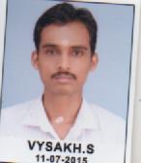 | O+ | Sankaran Kutty K.M | Sailaja P.K | Sreesailam, Ayikkarapady Post, Malappuram Dist., KERALA-673637  9847932281 | Male | Sreesailam, Ayikkarapady Post, Malappuram Dist., KERALA-673637  9847932281  drvysakhsankar@gmai.com | General Merit | Indian  Kerala | Management Seats | 0 | 0 | BAMS | 02A8237 | 28-05-2007 | Rajiv Gandhi University of Health Sciences, Karnataka | 2350 | 1335 | 09-12-2016 | 31-05-1985
7 | MD Ayurveda in Kayachikitsa | Dr. Satheesh Kumar N | 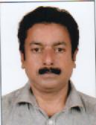 | A+ | C.N Neelakantan Namboothiri | C.N Vasanthy | Dhanwanthari Sadanam  Thodupuzha  Iduki Dist  KERALA-685584  9447497002, 9446359100 | Male | Dhanwanthari Sadanam  Thodupuzha  Iduki Dist  KERALA-685584  9447497002, 9446359100  satheesh@dhanwanthari.org | General Merit | Indian  Kerala | Management Seats | 0 | 0 | BAMS | 216 | 23-11-1990 | University of Kerala | 2400 | 1198 | 18-10-2016 | 09-05-1964
8 | MD Ayurveda in Kayachikitsa | Dr. Kurade Gopal Ramrao | 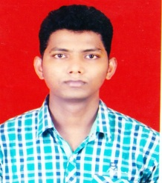 | O+ | Ramrao Rajaram Kurade | Sawdaka | Teem Dongari  Adarsh Nagar  OPP.A-1 Bekari,  Goregaon  West Mumbai  MAHARSHTRA-400104  9819992658 | Male | Teem Dongari  Adarsh Nagar  OPP.A-1 Bekari,  Goregaon  West Mumbai  MAHARSHTRA-400104  9819992658  kuradegopalramrao@gmail.com | General Merit | Indian  Maharashtra | Management Seats | 0 | 0 | BAMS | 1310290937 | 14-08-2014 | Maharashtra University of health science, Nash | 1850 | 1096 | 18-10-2016 | 10-06-1988
9 | MD Ayurveda in Kayachikitsa | Dr. Kharat Dnyaneshwar Sheshrao | 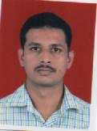 | A- | Kharat Sheshrao Bhujangrao | Kharat Laxmi Shesrao | At.Post Shivanitaka  Ta. Sindkhed Raja  Dist.- Buldhana  MAHARASHTRA-443203  9970389069 | Male | At.Post Shivanitaka  Ta. Sindkhed Raja  Dist.- Buldhana  MAHARASHTRA-443203  9970389069  Drdnyan32k@gmail.com | General Merit | Indian  Maharashtra | Management Seats | 0 | 0 | BAMS | 03A2626 | 29-03-2010 | Rajiv Gandhi University of Health Sciences, Karnataka | 1800 | 1127 | 24-10-2016 | 29-12-1984
10 | MD Ayurveda in Kayachikitsa | Dr. Kalwane Deepali Balaji | 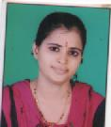 | O+ | Balaji Kalwane | Mahananda | Shivkrupa Niwas  Shivkalyan nagar  Loha T.Q  Nanded Dist  MAHARASHTRA  7798761711 | Female | Shivkrupa Niwas  Shivkalyan nagar  Loha T.Q  Nanded Dist  MAHARASHTRA  7798761711  deepalibalaji@gmail.com | General Merit | Indian  Maharashtra | Management Seats | 0 | 0 | BAMS | 07A3611 | 10-09-2012 | Rajiv Gandhi University of Health Sciences, Karnataka | 2350 | 1560 | 24-10-2016 | 13-06-1989
11 | MD Ayurveda in Kayachikitsa | Dr. Avinash S. | 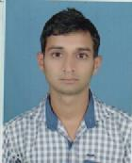 | AB+ | Thirumaleshwara Bhat S | Laxmi K | Shanthimoole House, Manikkar Post & Village, Bellare, Sullia T.Q., D.K Dist., Karnataka- 574 212  8762121216 | Male | Shanthimoole House, Manikkar Post & Village, Bellare, Sullia T.Q., D.K Dist., Karnataka- 574 212  8762121216 | General Merit | Indian  Karnataka  Rural | GS-Government Seats | 74 | 74 | BAMS | 10A0656 | 29-04-2015 | Rajiv Gandhi University of Health Sciences, Karnataka | 2350 | 1577 | 21-11-2016 | 06-09-1992
12 | MD Ayurveda in Panchakarma | Dr.Abhijith T.G. | 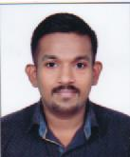 | B+ | Gopi T.V | Uma P.S | Thottupurath House  Nhamanghat Post  Trissur Dist  KERALA-679563  9980648368 | Male | Thottupurath House  Nhamanghat Post  Trissur Dist  KERALA-679563  9980648368  Dr.abhijithjopl@gmail.com | General Merit | Indian  Kerala | Management Seats | 0 | 0 | BAMS | 10A6301 | 29-04-2015 | Rajiv Gandhi University of Health Sciences, Karnataka | 2350 | 1518 | 14-10-2016 | 03-12-1992
13 | MD Ayurveda in Panchakarma | Dr. Chaudhari Rashmi Manjaji | 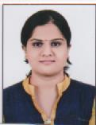 | B+ | Chaudhari Manjaji Sheshrao | Sunanda | Jijamata Place  Tal- Sinkhedraja  Dist- Buldana  MAHARASHTRA | Female | Jijamata Place  Tal- Sinkhedraja  Dist- Buldana  MAHARASHTRA  Rashmichaudhari20@gmail.com | General Merit | Indian  Maharashtra | Management Seats | 0 | 0 | BAMS | 1310292791 | 13-03-2014 | Maharashtra University of health science, Nash | 1860 | 1052 | 17-10-2016 | 20-05-1991
14 | MD Ayurveda in Panchakarma | Dr. Thushara Saju | 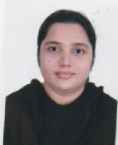 | A+ | Saju Joseph | Alphonsa Saju | Kallatt House  Muyyam Post  Taliparamba  Kannur Dist  KERALA-670142 9447322834, 9633281853 | Female | Kallatt House  Muyyam Post, Taliparamba  Kannur Dist  KERALA-670142  9447322834, 9633281853  roseann_saju@yahoo.com | Category IIA | Indian  Kerala | Management Seats | 0 | 0 | BAMS | 14996 | 27-04-2013 | Kannur University, Kerala | 1850 | 1166 | 20-10-2016 | 09-06-1989
15 | MD Ayurveda in Panchakarma | Dr. Sherly Joy | 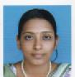 | A+ | K.G Joy Kutty | Mary Kutty | K.P. House  Muthupilakkadu Post  Kollam Dist-690520  0476-2834491 | Female | K.P. House  Muthupilakkadu Post  Kollam Dist-690520  0476-2834491  joysherly@gmail.com | Category IIA | Indian  Kerala | Management Seats | 0 | 0 | BAMS | 08A2946 | 10-10-2016 | Rajiv Gandhi University of Health Sciences, Karnataka | 2350 | 1466 | 22-10-2016 | 28-04-1991
16 | MD Ayurveda in Panchakarma | Dr. Achuth Panicker | 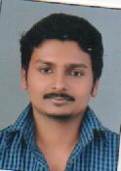 | O+ | P.K Anil Kumar | Anitha S.R | Valacodu Post  Kollam Dist  KERALA- 691331 | Male | Valacodu Post  Kollam Dist  KERALA- 691331  9061414197  achuthpanicker@001gmail.com | General Merit | Indian  Kerala | Management Seats | 0 | 0 | BAMS | 10A1001 | 11-07-2016 | Rajiv Gandhi University of Health Sciences, Karnataka | 2350 | 1431 | 24-10-2016 | 21-09-1992
17 | MD Ayurveda in Panchakarma | Dr. Abhijit Kumar Sinha | 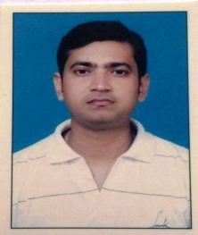 | B+ | A.K Sinha | Sova Sinha | 83 Ramesh Goswami Road Kancharapara West Bengal 743145 | Male | 83 Ramesh Goswami Road Kancharapara West Bengal-743145  dr.abhijit.k.sinha@gmail.com | General Merit | Indian  West Bengal | Management Seats | 0 | 0 | BAMS | 38 | 12-04-2007 | University of Calcutta | 1850 | 1146 | 31.12.2016 | 31-01-1982
18 | MS Ayurveda in Shalyatantra | Dr. Manish Kumar Tiwari | 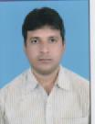 | AB+ | L. Sachidanand Tiwari | Tiwari | Pamapur Village  Barthrakalan Post  Varnasi Dist  Utter Pradesh  9836090538 | Male | Pamapur Village  Barthrakalan Post  Varnasi Dist  Utter Pradesh  9836090538  Manishwr483@gmail.com | General Merit | Indian  Uttar Pradesh | Management Seats | 0 | 0 | BAMS | 55687 | 15-08-2008 | University of Calcutta | 1850 | 1158 | 17-10-2016 | 16-01-1983
19 | MS Ayurveda in Shalyatantra | Dr. Shailendra Pratap Chaudhari | 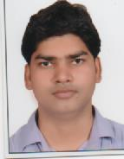 | B+ | Fekan Ram | Sharda Devi | SA-6/112-1A  JD Nagar  Collomey Aktha Pahariya  Sarmath Varanasi  Uttar Pradesh-221007  9889775530 | Male | SA-6/112-1A  JD Nagar  Collomey Aktha Pahariya  Sarmath Varanasi  Uttar Pradesh-221007  9889775530  s.p.chaudhari08@gmail.com | Schedule Caste | Indian  Uttar Pradesh | Management Seats | 0 | 0 | BAMS | 9310118 | 04-09-2013 | Chhatrapati Shahu Ji Maharaj University, Kanpur | 1850 | 1146 | 20-10-2016 | 14-07-1989
20 | MS Ayurveda in Shalyatantra | Dr. A Srinivasan | 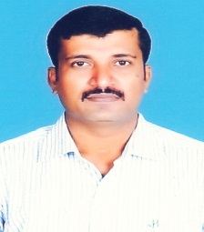 | B+ | P. Ayyasamy | A. Gnanambal | No.155  Anbu Nagar  Koothampoondi Post  Bavani TQ  Erode Dist  Tamil Nadu -638315  9865331215 | Male | No.155  Anbu Nagar  Koothampoondi Post  Bavani TQ  Erode Dist  Tamil Nadu -638315  9865331215  drsrinivasan@gmail.com | General Merit | Indian  Tamil Nadu | Management Seats | 0 | 0 | BAMS | 64971210 | 05-11-2002 | Tamil Nadu Dr.NGR Medical University Chennai | 3970 | 2210 | 20-10-2016 | 16-05-1978
21 | MS Ayurveda in Shalyatantra | Dr. Ashish Kumar | 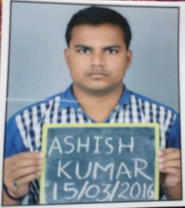 | O+ | Rajendra Prasad Singh | Sudha Singh | Post Purshottampur Narayanpur Mizapur, Uttar Pradesh -231 305  8416997784 | Male | Post Purshottampur Narayanpur Mizapur, Uttar Pradesh -231 305  8416997784  Singh.ahish748@gmail.com | General Merit | Indian  Uttar Pradesh | Management Seats | 0 | 0 | BAMS | 10158AY017 | 18-02-2015 | Banaras Hindu University | 1850 | 1087 | 25-10-2016 | 02-01-1989
22 | MS Ayurveda in Shalyatantra | Dr. Vinaykumar D.R. | 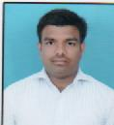 | B+ | Ramachandrappa R | Sujathsmma H | Devigere Village & Post, HosadurgaTaluk, Chitradurga Dist., Karnataka – 577527  9980908522 | Male | Devigere Village & Post, HosadurgaTaluk, Chitradurga Dist., Karnataka – 577527  9980908522  Dr.vinaykumar93@gmail.com | Category IIA | Indian  Karnataka  Rural | GS-Government Seats | 168 | 168 | BAMS | 10A0694 | 29-04-2015 | Rajiv Gandhi University of Health Sciences, Karnataka | 2350 | 1544 | 28-11-2016 | 13-05-1993
23 | MS Ayurveda in Shalyatantra | Dr.Ramesh Harimohan | 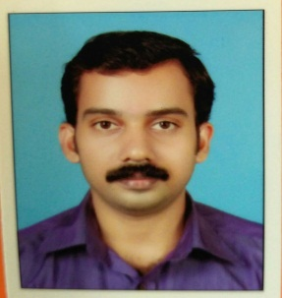 | O+ | Harimohan T.R | Geetha S | AMC 18/IV A,S.R.K Villas Nazrethlane Alwaya Road Angamaly post Ernakulam Dist. Kerala  8281936428 | Male | AMC 18/IV A,S.R.K Villas Nazrethlane Alwaya Road Angamaly post Ernakulam Dist. Kerala  8281936428  drrameshharimohan@gmail.com | General Merit | Indian  Kerala | Management Seats | 0 | 0 | BAMS | 130302037 | 20-06-2008 | Chandrashekharendra Saraswathi Viswa Mahavidyalaya | 1850 | 1076 | 31-12-2016 | 28-05-1984
24 | MD Ayurveda in Agada Tantra | Dr. Krishnanunny K.P. | 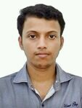 | O+ | Pradeep Kumar S | Vijayakumari T.M | Kumpithodil House  Naduvathucherry  Chavara South Post  Vadakkumbhagom  Kollam Dist  KERALA-691584  98809659829/9846500987 | Male | Kumpithodil House  Naduvathucherry  Chavara South Post  Vadakkumbhagom  Kollam Dist  KERALA-691584  98809659829/9846500987  Krishna.unny@yahoo.in | General Merit | Indian  Kerala | Management Seats | 0 | 0 | BAMS | 07A7311 | 10-09-2012 | Rajiv Gandhi University of Health Sciences, Karnataka | 2350 | 1373 | 14-10-2016 | 17-05-1990
25 | MD Ayurveda in Agada Tantra | Dr. Midhun M.Nair | 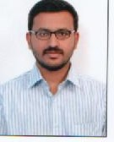 | O+ | Manoharan Nair P.K | Ajitha Manoharan | Pawakkarayil  Thengumkavu  Konni, Pathanamthitta Dist, Kerala-689646  8754911804 | Male | Pawakkarayil  Thengumkavu  Konni, Pathanamthitta Dist, Kerala-689646  8754911804  Midhun1221@gmail.com | General Merit | Indian  Kerala | Management Seats | 0 | 0 | BAMS | 06A2727 | 28-09-2011 | Rajiv Gandhi University of Health Sciences, Karnataka | 2350 | 1375 | 14-10-2016 | 02-10-1988
26 | MD Ayurveda in Agada Tantra | Dr. Parvathy J.L | 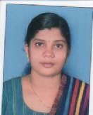 | O+ | D. Jayanandan | C.D Lali | Dakshalayam  TC.31/1028(5)  Pettah Post  Trivandrum Dist  KERALA- 695024  9847400183/ 9847320018 | Female | Dakshalayam  TC.31/1028(5)  Pettah Post  Trivandrum Dist  KERALA- 695024  9847400183/ 9847320018  jlparvathy@gmail.com | General Merit | Indian  Kerala | Management Seats | 0 | 0 | BAMS | 25454 | 29-11-2013 | University of Kerala | 1850 | 1028 | 15-10-2016 | 30-04-1989
27 | MD Ayurveda in Agada Tantra | Dr. Syam Dayal V | 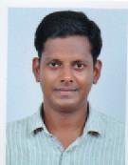 | AB+ | Vasudevan Nair P | Sreekumary R | Sreesanthi  Kulakkada Post  Kollam Dist  KERALA- 691521  9846162562 | Male | Sreesanthi  Kulakkada Post  Kollam Dist  KERALA- 691521  9846162562  vsyamdayal@gmail.com | General Merit | Indian  Kerala | Management Seats | 0 | 0 | BAMS | 05A3876 | 08-04-2010 | Rajiv Gandhi University of Health Sciences, Karnataka | 2350 | 1406 | 21-10-2016 | 27-04-1987
28 | MD Ayurveda in Agada Tantra | Dr. Supriya S. | 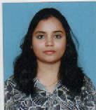 | O+ | Sathyendra Swamy S. | Sheela Kumari N.T | Harave Mutt, Harave,  Chamaraja Nagar Taluk & District.,  Karnataka-571128  7829577957 | Female | Harave Mutt, Harave,  Chamaraja Nagar Taluk & District.,  Karnataka-571128  7829577957  Supriya.s977@yahoo.in | Category IIIB | Indian  Karnataka  Rural | GS-Government Seats | 186 | 186 | BAMS | 10A4235 | 27-03-2016 | Rajiv Gandhi University of Health Sciences, Karnataka | 2350 | 1774 | 22-11-2016 | 29-12-1992
29 | MD Ayurveda in Rasashastra & Bhaishajya Kalpana | Dr.Salu Sasi | 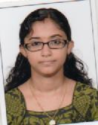 | B+ | P.V Sasi | Lalitha Sasi | Poovathusseriyil House  Erumely  Kanjirapally TQ  Kottayam Dist  KERALA-686509  9400410133 | Female | Poovathusseriyil House  Erumely  Kanjirapally TQ  Kottayam Dist  KERALA-686509  9400410133  pvsalusasi@gmail.com | General Merit | Indian  Kerala | Management Seats | 0 | 0 | BAMS | 1128 | 22-11-2011 | University of Calicut | 1850 | 1236 | 14-10-2016 | 27-12-1987
30 | MD Ayurveda in Rasashastra & Bhaishajya Kalpana | Dr. Naila C. Azad | 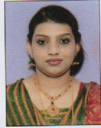 | B+ | Azad C.A | Fousia Azad | Valiyakath House  Chiyyaram Post  Thrissur Dist  KERALA  7559978910 | Female | Valiyakath House  Chiyyaram Post  Thrissur Dist  KERALA  7559978910  Dr.nylzfru@gmail.com | Category IIB | Indian  Kerala | Management Seats | 0 | 0 | BAMS | 05A1818 | 07-04-2010 | Rajiv Gandhi University of Health Sciences, Karnataka | 2350 | 1605 | 17-10-2016 | 19-03-1986
31 | MD Ayurveda in Rasashastra & Bhaishajya Kalpana | Dr. Praveen M | 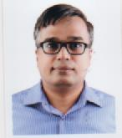 | B- | E.P Unnikrishna Varrier | Chandrika M. | Gayathri  Poozhithara  Kottakkal Post  Malappuram Dist  KERALA  9746136470 | Male | Gayathri  Poozhithara  Kottakkal Post  Malappuram Dist  KERALA  9746136470  Varier.praveen@gmail.com | General Merit | Indian  Kerala | Management Seats | 0 | 0 | BAMS | 8057 | 17-10-1998 | University of Calicut | 1850 | 1057 | 17-10-2016 | 04-12-1971
32 | MD Ayurveda in Rasashastra & Bhaishajya Kalpana | Dr. Ajith C. Vijai | 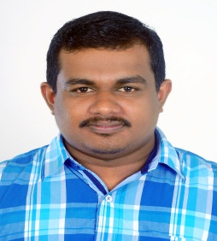 | O+ | C.K Vijayakumar | Leela | Chirackal House, Muttom Post, Idukki Dist.,  Kerala-685 587 | Male | Chirackal House, Muttom Post, Idukki Dist.,  Kerala-685 587 | General Merit | Indian  Kerala | Management Seats | 0 | 0 | BAMS | 6201 | 14-03-2013 | University of Calicut | 1850 | 1011 | 27-10-2016 | 15-03-1988
33 | MD Ayurveda in Rasashastra & Bhaishajya Kalpana | Dr. Sourish Das | 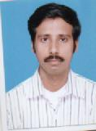 | O+ | Sasanka Das | Anjali Das | Palpara Village, P.O & P.S- Chakdaha, Naida Dist., West Bengal – 741 222  7501066643 | Male | Palpara Village, P.O & P.S- Chakdaha, Naida Dist., West Bengal – 741 222  7501066643  Sourishdas56@gmail.com | General Merit | Indian  West Bengal | Management Seats | 0 | 0 | BAMS | 11845 | 14-05-2009 | The Bengal University of Health Science | 1850 | 1229 | 18-11-2016 | 29-07-1985
34 | MD Ayurveda in Rasashastra & Bhaishajya Kalpana | Dr. Lekha Baburajan | 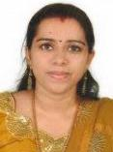 | B- | Baburajan | Sreelatha Babu | Prakash Bhavan, Pallichal Road, Thoppumpady, Kochi- 682005  9846910007 | Female | Prakash Bhavan, Pallichal Road, Thoppumpady, Kochi- 682005  9846910007  Drlekharaj14@gmail.com | General Merit | Indian  Kerala | Management Seats | 0 | 0 | BAMS | 01A8824 | 12-06-2006 | Rajiv Gandhi University of Health Sciences, Karnataka | 2350 | 1540 | 07-12-2016 | 27-05-1982

