KVG Ayurveda Medical College & Hospital Sullia Dk
PG Students list-2017-18

SN | Course | Name  *Remarks if any... | Photo | Blood Group | Father Name | Mother Name | Permanent Address  Phone Number | Sex | Student Adress  Cell No.  Email ID | Caste | Nationality | Seat  Category | PGET  Rank | PGET  % | Qualifying  Exam | Register  No. | Passed  year | University/  Board | Max  Marks | Sec.  Marks | Date  of  Admission | Date  of  Birth
1 | MD Ayurveda in Dravyaguna | Dr. Karthika S | 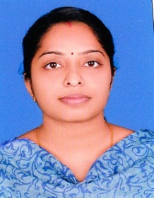 | B+ | M.S. Sasidharan | Pushpaletha P.V | Puthiyamadom Venduvazhi Karukadom Post Kothamangalam Ernakulam Dist KERALA Pin: 686691 | Female | Puthiyamadom Venduvazhi Karukadom Post Kothamangalam Ernakulam Dist KERALA Pin: 686691  9495150824  drkarthika3010@gmail.com | General Merit | Indian  Kerala | Management Seats | 0 | 0 | BAMS | 1573 | 10-03-2009 | Kannur University | 1850 | 1202 | 18-08-2017 | 30-10-1985
2 | MD Ayurveda in Dravyaguna | Dr. Shankar Prasanth | 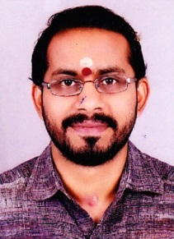 | B- | S. Subramaniyan Moosad | Leeladevi | Pallipattu Illom Thanneermukkom Post Alappuzha Dist KERALA Pin: 688527 Ph: 9895443112 | Male | Pallipattu Illom Thanneermukkom Post Alappuzha Dist KERALA Pin: 688527 Ph: 9895443112  9895444229  drshankarsp@gmail.com | General Merit | Indian  Kerala | Management Seats | 0 | 0 | BAMS | 04A9233 | 26-02-2009 | Rajiv Gandhi University of Health Sciences, Karnataka | 2350 | 1515 | 22-08-2017 | 12-12-1984
3 | MD Ayurveda in Dravyaguna | Dr. Suresh V | 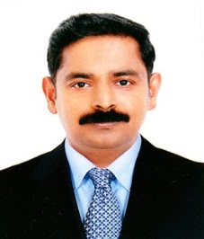 | O+ | Viswakumar | Padma | Lavanya Pattanakad Post Cherthala Alapuzha Dist KERALA Pin: 688531, 00971529189098 | Male | Lavanya Pattanakad Post Cherthala Alapuzha Dist KERALA Pin: 688531, 00971529189098  9496109565  sureshviswakumar@gmail.com | General Merit | Indian  Kerala | Management Seats | 0 | 0 | BAMS | 309 | 26-11-1997 | University of Kerala | 1850 | 1128 | 04-10-2017 | 12-09-1972
4 | MD Ayurveda in Dravyaguna | Dr. Divin Mathew | 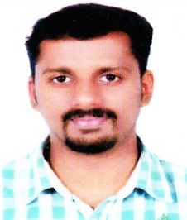 | O+ | M.M. Mathew | Daisy Mathew | Manjathanam House Pilathara Post Cherutazham Kannur Dist KERALA Pin: 670504 | Male | Manjathanam House Pilathara Post Cherutazham Kannur Dist KERALA Pin: 670504  8281692079  dnadun@gmail.com | General Merit | Indian  Kerala | Management Seats | 0 | 0 | BAMS | 09A2333 | 29-04-2015 | Rajiv Gandhi University of Health Sciences, Karnataka | 2350 | 1365 | 26-10-2017 | 20-07-1991
5 | MD Ayurveda in Dravyaguna | Dr. Prathika K | 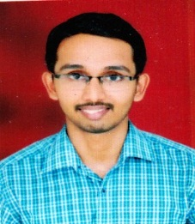 | A+ | Vishnu Bhat | Veena | Kunchinadka House Katukukke Post Kasaragod Dist KERALA Pin: 671552 | Male | Kunchinadka House Katukukke Post Kasaragod Dist KERALA Pin: 671552  9481263438  prathikk93@gmail.com | General Merit | Indian  Kerala | GS-Government Seats | 75 | 52.61 | BAMS | 11A0936 | 24-10-2016 | Rajiv Gandhi University of Health Sciences, Karnataka | 2350 | 1667 | 31-10-2017 | 06-08-1993
6 | MD Ayurveda in Dravyaguna | Dr. Shini Babu | 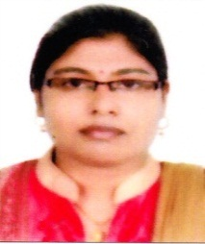 | A+ | N O Babu | Leelamma Babu | Beacon Villa, Elanjimel North Post, Elanjimel, Chengannur Taluk, Alleppey Dist., Kerala-689511 | Female | Beacon Villa, Elanjimel North Post, Elanjimel, Chengannur Taluk, Alleppey Dist., Kerala-689511  9744742814  shinibabu123@gmail.com | General Merit | Indian  Kerala | GS-Government Seats | 651 | 651 | BAMS | 11A4830 | 24-10-2016 | Rajiv Gandhi University of Health Sciences, Karnataka | 2350 | 1530 | 22-11-2017 | 08-05-1991
7 | MD Ayurveda in Kayachikitsa | Dr. Gopika S.V. Gokul | 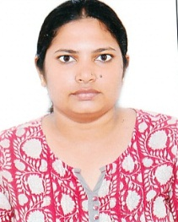 | O- | Vasudevan E | Sandhya V Nair | Gokulam House Kizhakkummuri Post Kakkodi Calicut Dist KERALA Pin: 673611 Ph: 9048274168 | Female | Gokulam House Kizhakkummuri Post Kakkodi Calicut Dist KERALA Pin: 673611 Ph: 9048274168  9400965079  badhra.v.nair@gmail.com | General Merit | Indian  Kerala | Management Seats | 0 | 0 | BAMS | 09A6617 | 16-01-2015 | Rajiv Gandhi University of Health Sciences, Karnataka | 2350 | 1515 | 07-10-2017 | 29-05-1992
8 | MD Ayurveda in Kayachikitsa | Dr. Nirmal Kanakaraj | 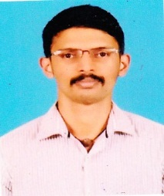 | O+ | Kanakaraj T P | Lakshmi Priya C S | Devi Kripa Kizhuthally Thazhe chovva Post Kannur Dist KERALA Pin: 670018 Ph: 9744444246 | Male | Devi Kripa Kizhuthally Thazhe chovva Post Kannur Dist KERALA Pin: 670018 Ph: 9744444246  8880735317  nirmalkanakaraj14@gmail.com | General Merit | Indian  Kerala | Management Seats | 0 | 0 | BAMS | 10A2349 | 29-04-2015 | Rajiv Gandhi University of Health Sciences, Karnataka | 2350 | 1512 | 29-08-2017 | 14-04-1993
9 | MD Ayurveda in Kayachikitsa | Dr. Jisha K | 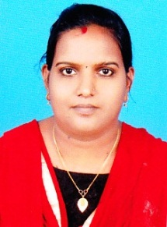 | AB+ | Sugathan P.V. | Prabhavathi | Narayana Aduthila Ezome Village Kannur Dist KERALA Pin: 670303 | Female | Narayana Aduthila Ezome Village Kannur Dist KERALA Pin: 670303  9544569999  drjishak@gmail.com | General Merit | Indian  Kerala | Management Seats | 0 | 0 | BAMS | 04A4420 | 26-02-2009 | Rajiv Gandhi University of Health Sciences, Karnataka | 2350 | 1574 | 31-08-2017 | 20-12-1986
10 | MD Ayurveda in Kayachikitsa | Kalleshkumar Hiremath | 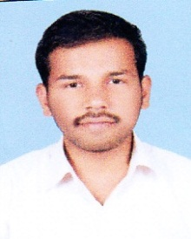 | O+ | Basavaraj | Kavita | Mushigeri Post Ron TQ Gadag Dist KARNATAKA Pin: 582211 | Male | Mushigeri Post Ron TQ Gadag Dist KARNATAKA Pin: 582211  8884342814  hiremath360@gmail.com | Category IIIB | Indian  Karnataka  Urban | GS-Government Seats | 357 | 357 | BAMS | 11A1501 | 24-10-2016 | Rajiv Gandhi University of Health Sciences, Karnataka | 2350 | 1745 | 31-08-2017 | 24-08-1993
11 | MD Ayurveda in Kayachikitsa | Dr. Pooja D.G | 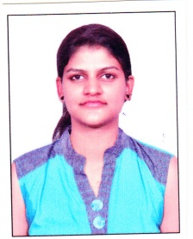 | O+ | Basavaraj D.G. | Shantha D.G | Shiva Krupa Nilaya Main Road Basavapattanna Channagiri TQ Davanagere Dist. KARNATAKA Pin: 577551 9008183869 poojadg45@gmail.com | Female | Shiva Krupa Nilaya Main Road Basavapattanna Channagiri TQ Davanagere Dist. KARNATAKA Pin: 577551 9008183869 poojadg45@gmail.com  9008183869  poojadg45@gmail.com | Category IIIB | Indian  Karnataka  Rural | GS-Government Seats | 207 | 207 | BAMS | 11A0626 | 24-10-2016 | Rajiv Gandhi University of Health Sciences, Karnataka | 2350 | 1662 | 31-10-2017 | 18-07-1993
12 | MD Ayurveda in Panchakarma | Dr. Manu.K. Mohan | 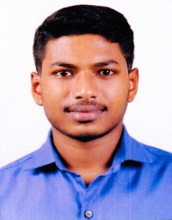 | A+ | K.D. Mohanakumar | Radhamony V.M | Kuttiparichathil House Muttuchira Post Kottayam Dist KERALA Pin: 686613 | Male | Kuttiparichathil House Muttuchira Post Kottayam Dist KERALA Pin: 686613  8089189319  go4manuk@gmail.com | General Merit | Indian  Kerala | Management Seats | 0 | 0 | BAMS | 10A1033 | 11-07-2016 | Rajiv Gandhi University of Health Sciences, Karnataka | 2350 | 1632 | 06-09-2017 | 22-09-1992
13 | MD Ayurveda in Panchakarma | Dr. Salmi Simon | 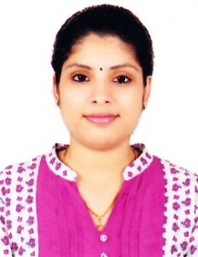 | AB+ | Simon C D | Pushpam M T | Chittilappilly House Elthuruth Post Thrissur Dist KERALA Pin: 680611 Ph: 048723366765 | Female | Chittilappilly House Elthuruth Post Thrissur Dist KERALA Pin: 680611 Ph: 048723366765  9995161322  arunarosekiron@gmail.com | General Merit | Indian  Kerala | Management Seats | 0 | 0 | BAMS | 11A2943 | 24-10-2016 | Rajiv Gandhi University of Health Sciences, Karnataka | 2350 | 1629 | 15-09-2017 | 09-06-1993
14 | MD Ayurveda in Panchakarma | Dr. Nibin Sajan | 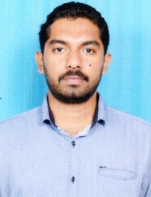 | B+ | Sajan O | Laila Sajan | Thempra Veedu Kottarakkara Puthoor Post Kollam Dist KERALA Pin: 691507 | Male | Thempra Veedu Kottarakkara Puthoor Post Kollam Dist KERALA Pin: 691507  8277378334  nibinsajan@gmail.com | General Merit | Indian  Kerala | Management Seats | 0 | 0 | BAMS | 11A1035 | 22-11-2016 | Rajiv Gandhi University of Health Sciences, Karnataka | 2350 | 1527 | 13-10-2017 | 04-04-1993
15 | MD Ayurveda in Panchakarma | Dr. Sonika Jarial | 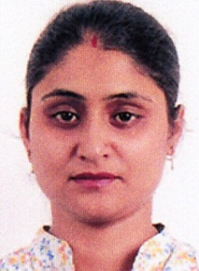 | A+ | Swaran Singh Jarial | Asha Jarial | Vill- Kuthera P.O. – Darkati Teh – Jawali Dist – Kangra Himachal Pradesh Pin: 176023 Ph: 8146198360 | Female | Vill- Kuthera P.O. – Darkati Teh – Jawali Dist – Kangra Himachal Pradesh Pin: 176023 Ph: 8146198360  9805959300  drsonikajarial@gmail.com | General Merit | Indian  Himachal Pradesh | Management Seats | 0 | 0 | BAMS | 08-BAK-43 | 17-07-2013 | Bhagat Phool Singh Mahila Vishwavidyalaya Khanpu | 1850 | 1161 | 20-10-2017 | 04-11-1989
16 | MD Ayurveda in Panchakarma | Dr. Sarika Chandrababu | 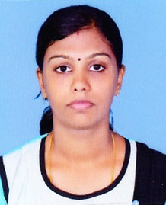 | A+ | Chandrababu K. | Sasikala K | Tra –III Mundakkal West Kollam Dist KERALA Pin: 691001 Ph: 8078068978 | Female | Tra –III Mundakkal West Kollam Dist KERALA Pin: 691001 Ph: 8078068978  8075465036  dr.sarikababu@gmail.com | General Merit | Indian  Kerala | Management Seats | 0 | 0 | BAMS | 15217 | 25-09-2014 | Kerala Unity | 1850 | 1269 | 09-09-2017 | 17-10-1989
17 | MD Ayurveda in Panchakarma | Dr. Sharadha | 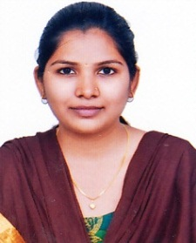 | B+ | Somaraya Talwar | Siddamma | H.No.- E/195 Gudur (SA) Tq- Jewargi Dist- Kalburgi KARNATAKA Pin: 585310 Ph: 8904433139 | Female | H.No.- E/195 Gudur (SA) Tq- Jewargi Dist- Kalburgi KARNATAKA Pin: 585310 Ph: 8904433139  9342355109  sharadhatalwar39@gmail.com | Category I | Indian  Karnataka  Rural | GS-Government Seats | 666 | 666 | BAMS | 11A1243 | 02-05-2017 | Rajiv Gandhi University of Health Sciences, Karnataka | 2350 | 1581 | 31-10-2017 | 12-07-1992
18 | MS Ayurveda in Shalyatantra | Dr. Rahul Mishra | 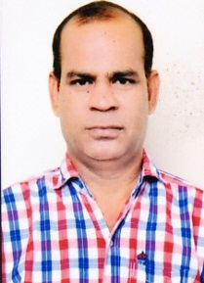 | O+ | Chandra Deo Mishra | Bindumathi Mishra | Vill & Po. Lohta Varanasi Uttar Pradesh Pin : 221107 | Male | Vill & Po. Lohta Varanasi Uttar Pradesh Pin : 221107  9336323284  misramanorama9@gmail.com | General Merit | Indian  Uttar Pradesh | Management Seats | 0 | 0 | BAMS | 48397 | 27-06-2002 | Kanpur Unity | 1850 | 1148 | 23-09-2017 | 11-07-1972
19 | MS Ayurveda in Shalyatantra | Dr. Anagha Deepthi G. | 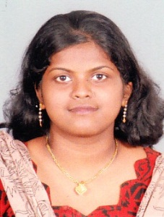 | B+ | Gopalan | K.M. Lilamma | Surabhi Kudamalloor Kottayam Dist KERALA Pin: 686017 | Female | Surabhi Kudamalloor Kottayam Dist KERALA Pin: 686017  9497897422  deepthianagha33@gmail.com | General Merit | Indian  Kerala | Management Seats | 0 | 0 | BAMS | 16529 | 24-01-2015 | Mahatma Gandhi University Kerala | 1850 | 1086 | 10-10-2017 | 31-05-1991
20 | MS Ayurveda in Shalyatantra | Dr. Rishika Sharma | 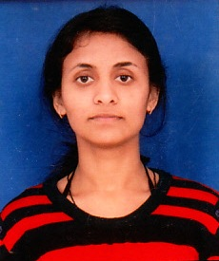 | A+ | Kulbhushan Sharma | Neelam Sharma | V.P.O. Nagrotasurian Teh. Jawali Kangra Himachal Pradesh Pin: 176027 | Female | V.P.O. Nagrotasurian Teh. Jawali Kangra Himachal Pradesh Pin: 176027  9466177512  drrishikas@gmail.com | General Merit | Indian  Himachal Pradesh | Management Seats | 0 | 0 | BAMS | 10080133 | 09-06-2015 | Bhagat Phool Singh Mahila Vishwavidyalaya Khanpu | 1850 | 1276 | 17-10-2017 | 24-12-1992
21 | MS Ayurveda in Shalyatantra | Dr. Renu Roy | 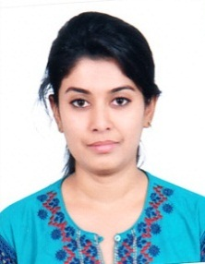 | O+ | Roy S.K. | Rekha Roy | Devi Nagar 2nd cross W.No. 34 Bellary KARNATAKA Pin: 583104 | Female | Devi Nagar 2nd cross W.No. 34 Bellary KARNATAKA Pin: 583104  9886101063  renroy08@gmail.com | Category IIA | Indian  Karnataka  Rural | GS-Government Seats | 660 | 660 | BAMS | 10A4230 | 11-07-2016 | Rajiv Gandhi University of Health Sciences, Karnataka | 2350 | 1680 | 31-10-2017 | 03-11-1992
22 | MS Ayurveda in Shalyatantra | Dr. Rajeshwari | 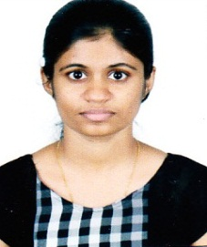 | A+ | Pavithran C.V. | Rajalakshmi | Prasad Nivas Hosmar Post Karkala Udupi Dist KARNATAKA Pin: 574107 | Female | Prasad Nivas Hosmar Post Karkala Udupi Dist KARNATAKA Pin: 574107  9480333016  aryapavithran92@gmail.com | Category IIA | Indian  Karnataka  Rural | GS-Government Seats | 272 | 272 | BAMS | 10A0951 | 11-07-2016 | Rajiv Gandhi University of Health Sciences, Karnataka | 2350 | 1616 | 31-10-2017 | 04-11-1992
23 | MS Ayurveda in Shalyatantra | Dr. Anjitha S Kumar | 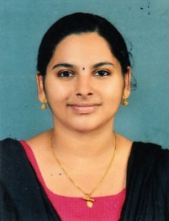 | B+ | P.S. Satheesh Kumar | P.N. Satadamony | Puthettu House Manakkad Post Thodupuzha Iduki Dist KERALA Pin : 685608 | Female | Puthettu House Manakkad Post Thodupuzha Iduki Dist KERALA Pin : 685608  7736414375  anjithasatheesh92@gmail.com | General Merit | Indian  Kerala | Management Seats | 0 | 0 | BAMS | 64101104 | 27-10-2015 | Chennai Unity | 1850 | 1184 | 04-10-2017 | 27-06-1992
24 | MD Ayurveda in Agada Tantra | Dr. Srijith M | 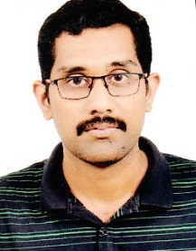 | O+ | Srinivasan T P | Vijayalakshmi M | Prabha Nivas Munduparamba Post Malappuram Dist KERALA Pin: 676509, Ph-7034165079 | Male | Prabha Nivas Munduparamba Post Malappuram Dist KERALA Pin: 676509, Ph-7034165079  8891451009  Sri111222@gmail.com | General Merit | Indian  Kerala | Management Seats | 0 | 0 | BAMS | 05A1842 | 07-04-2010 | Rajiv Gandhi University of Health Sciences, Karnataka | 2350 | 1396 | 24-08-2017 | 28-01-1988
25 | MD Ayurveda in Agada Tantra | Dr. Sarath S | 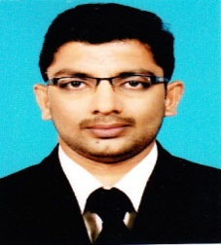 | AB+ | Soolapani T.V. | Ramani M.V | Sreepadam House Thalamunda Edappal Post Malappuram Dist KERALA Ph: 9633918421 | Male | Sreepadam House Thalamunda Edappal Post Malappuram Dist KERALA Ph: 9633918421  9656363588  drsarathsreepadam@gmail.com | General Merit | Indian  Kerala | Management Seats | 0 | 0 | BAMS | 130402038 | 29-07-2009 | Sri Chandrasekharendra Saraswathi Iswa Mahavidya | 1850 | 1134 | 26-08-2017 | 30-05-1987
26 | MD Ayurveda in Agada Tantra | Dr. Shiva Shankar A.M | 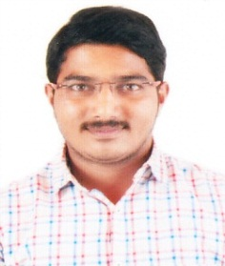 | B+ | A. N. Mallesh | Chandrakala | Mallesh A.N. UIICO Ltd KM Road Chikkamagaluru Dist KARNATAKA Pin: 577101 Ph: 9164779094 | Male | Mallesh A.N. UIICO Ltd KM Road Chikkamagaluru Dist KARNATAKA Pin: 577101 Ph: 9164779094  8762427625  - | General Merit | Indian  Karnataka  Urban | Management Seats | 0 | 0 | BAMS | 10A2188 | 11-07-2016 | Rajiv Gandhi University of Health Sciences, Karnataka | 2350 | 1419 | 04-09-2017 | 25-04-1992
27 | MD Ayurveda in Agada Tantra | Dr. Roshan D.A. | 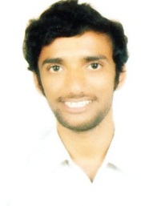 | A+ | Ananda Rai | Sumithra | 3-112, Devinagara Keyyuru , Madavu Puttur TQ Dakshina Kannada Dist KARNATAKA Pin: 574210 | Male | 3-112, Devinagara Keyyuru , Madavu Puttur TQ Dakshina Kannada Dist KARNATAKA Pin: 574210  9916972747  roshanda99@gmail.com | Category IIIB | Indian  Karnataka  Rural | Management Seats | 0 | 0 | BAMS | 11A2132 | 24-10-2016 | Rajiv Gandhi University of Health Sciences, Karnataka | 2350 | 1426 | 29-08-2017 | 30-05-1994
28 | MD Ayurveda in Agada Tantra | Dr. Anjali Nandakumar | 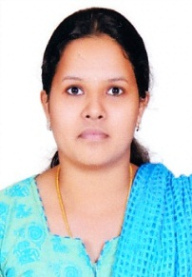 | B+ | Nandakumar E | Sasikala nandakumar | Elamuttath House Nellankara Nettissery Post Thrissur Dist KERALA Pin: 680657 Ph: 82816838 | Female | Elamuttath House Nellankara Nettissery Post Thrissur Dist KERALA Pin: 680657 Ph: 82816838  9447668955  anjali.nandha@gmail.com | General Merit | Indian  Kerala | GS-Government Seats | 169 | 169 | BAMS | 17105 | 30-04-2016 | Rajiv Gandhi University of Health Sciences, Karnataka | 2350 | 1659 | 25-10-2017 | 10-11-1992
29 | MD Ayurveda in Rasashastra & Bhaishajya Kalpana | Dr. Anjaly Gopinath | 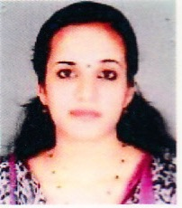 | O- | C. Gopinath | Jayashree Gopinath | Sreenandanam Puduvath House Mattathurkunnu Post Kadakara Via Thrissur Dist KERALA Pin: 680684 | Female | Sreenandanam Puduvath House Mattathurkunnu Post Kadakara Via Thrissur Dist KERALA Pin: 680684  8547433252  anjalijishnu18@gmail.com | General Merit | Indian  Kerala | Management Seats | 0 | 0 | BAMS | 387 | 23-03-2016 | Unity of Calicut | 1850 | 976 | 12-09-2017 | 30-12-1990
30 | MD Ayurveda in Rasashastra & Bhaishajya Kalpana | Dr. Karthik M.S. | 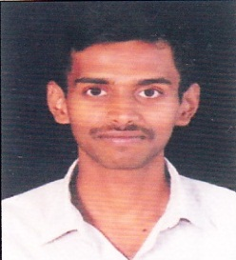 | O+ | Subrahmanya M | Vasanthi M.S. | Malethody Palthady Post & Village Puttur TQ Dakshina Kannada Dist KARNATAKA Pin: 574210 | Male | Malethody Palthady Post & Village Puttur TQ Dakshina Kannada Dist KARNATAKA Pin: 574210  9743295431  drkarthikbhat@gmail.com | General Merit | Indian  Karnataka  Urban | Management Seats | 0 | 0 | BAMS | 08A0922 | 03-04-2013 | Rajiv Gandhi University of Health Sciences, Karnataka | 2350 | 1615 | 30-08-2017 | 23-03-1991
31 | MD Ayurveda in Rasashastra & Bhaishajya Kalpana | Dr. Hari Radhakrishna Pillai | 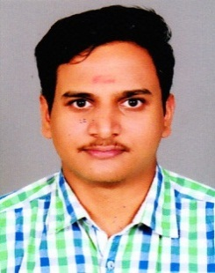 | O+ | K.G. Radhakrishnapillai | Thara Sumathikuttayamma | Krishnendu Assarkkandam Idukki Post KERALA Pin: 685553 Ph: 9497094157 | Male | Krishnendu Assarkkandam Idukki Post KERALA Pin: 685553 Ph: 9497094157  9447989415  hariradhakrishnapillai@gmail.com | General Merit | Indian  Kerala | Management Seats | 0 | 0 | BAMS | 11081 | 01-09-2015 | Unity of Calicut | 1850 | 1047 | 15-09-2017 | 23-06-1989
32 | MD Ayurveda in Rasashastra & Bhaishajya Kalpana | Dr. Gopakumaran K | 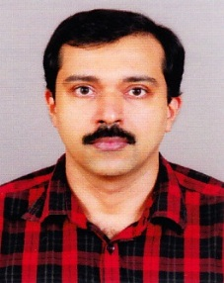 | B+ | K.Bhaskaran | K.Lakshmi | Chinmayi House Govindapuram Post Kozhikode Dist KERALA Pin : 673016 Ph: 09895067971 | Male | Chinmayi House Govindapuram Post Kozhikode Dist KERALA Pin : 673016 Ph: 09895067971  8075268336  doctorkripa@gmail.com | General Merit | Indian  Kerala | Management Seats | 0 | 0 | BAMS | 09 | 26-04-2000 | University of Kerala | 1850 | 1034 | 23-09-2017 | 30-05-1977
33 | MD Ayurveda in Rasashastra & Bhaishajya Kalpana | Dr. Vaisakh S | 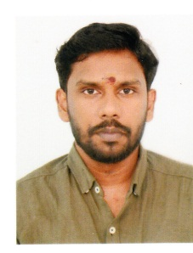 | B+ | D. Sudheesan | S. Sivakumari | TC 52/2324(1) NRA 75A Nemom Post Trivandrum Dist KERALA Pin: 695020 Ph: 9809724524 | Male | TC 52/2324(1) NRA 75A Nemom Post Trivandrum Dist KERALA Pin: 695020 Ph: 9809724524  8848945765  vaisakhanu@gmail.com | General Merit | Indian  Kerala | Management Seats | 0 | 0 | BAMS | 8048 | 15-07-2015 | Unity of Calicut | 1850 | 983 | 30-10-2017 | 07-11-1991
34 | MD Ayurveda in Rasashastra & Bhaishajya Kalpana | Dr. Chaitrashree Y.C. | 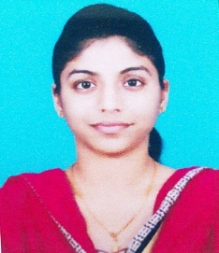 | A+ | Channegowda Y.C. | Asha Chowdamma | #6218 Guthal Colony Yathagadahalli Road 3rd cross Mandya Dist KARNATAKA Pin: 571403 Ph: 9590945780 | Female | #6218 Guthal Colony Yathagadahalli Road 3rd cross Mandya Dist KARNATAKA Pin: 571403 Ph: 9590945780  9590945780  ycchaitrashree@gmail.com | General Merit | Indian  Karnataka  Urban | GS-Government Seats | 414 | 414 | BAMS | 11A2923 | 24-10-2016 | Rajiv Gandhi University of Health Sciences, Karnataka | 2350 | 1767 | 31-10-2017 | 09-08-1992

